Exercise 5 Problems
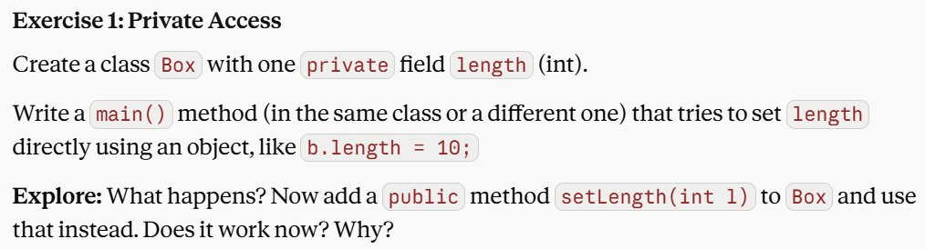

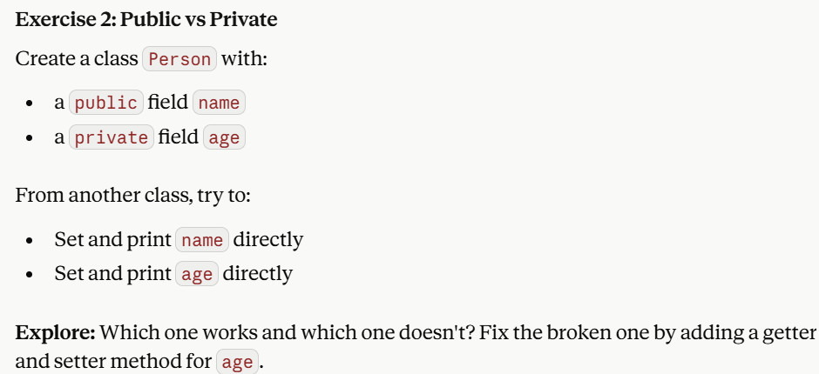

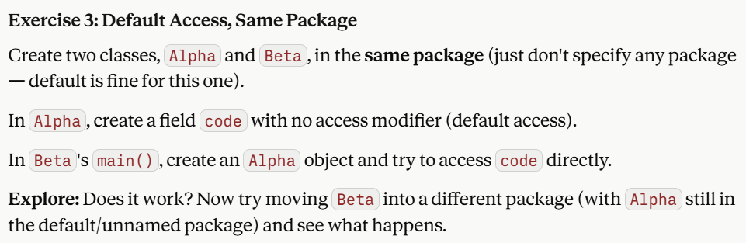

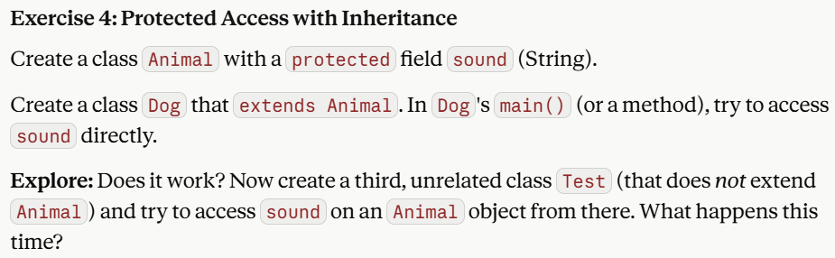
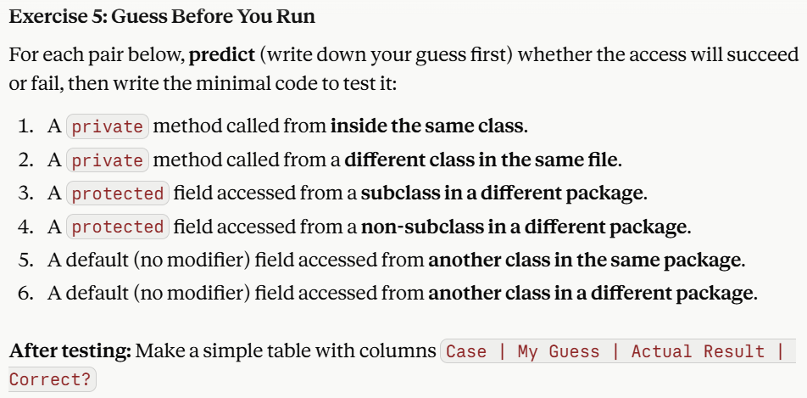
Exercise 6

Arithmetic Exception using try-catch
Write a Java program to read two integers and perform division. Handle the exception when the denominator is zero.
Exercise 7

Array Index out of Bounds Exception
Create an integer array of size 5. Read an index value from the user and display the array element. Handle invalid index values.
Exercise 8

Number Format Exception
Read a string from the user and converts it into an integer. Handle invalid numeric input.

Exercise 9

Multiple Exception Handling
Write a Java program that accepts two numbers and performs division. Handle different exceptions using multiple catch blocks.
Exceptions to handle:
- NullPointerException
- InputMismatchException
- StringIndexOutOfBoundsException

Exercise 10

Invalid Mark Exception
Create a custom exception InvalidMarkException.
Requirements:
- Accept student mark
- Marks should be between 0 and 100
- Otherwise throw exception

Exercise 11

File Reading using throws

Write a Java program to read data from a file. Use throws keyword to handle FileNotFoundException.

